Software Project Proposal
Program Name
Problem Definition (“Requirements”)
  - Describe the problem / task / game
  - Include a checklist of everything that the program will do
  - Include rules (for games)
Problem Analysis (“Design”)
  - Input and Output (list of all input/output from/to user, files, screen, etc.)
    - Layout of your main screen and at least two significant others
  - Java (and other object oriented languages):
    - Draw a hierarchy chart of the main program and its sub-programs (methods)
- Tasks should be broken down into different methods if possible
    - Show method headers (indicating parameters to be passed and return values)
  - Flash:
    - Describe the scenes (if used) and the purpose of the different frames in the main scene.
    - Hierarchy chart of your movieclips (and sub-movieclips if used)
    - Identify the event handlers required for each movieclip and describe what they will do.

Please see the attached example. The first parts are the same for Java and Flash projects. There are examples of the last part for both Java and Flash.
This is the design phase, so you are not required to stick to the breakdown that you specify here. You should, however, show evidence of good planning.
Example Project Proposal
Program Name SimplePONG
Problem Definition (“Requirements”)
SimplePONG is a game where a ball bounces inside a square arena. Players have rectangular paddles that they use to bounce the ball. If a player misses the ball and it goes off the edge off the screen, the other player gets a point. The player who scores the most points in 5 minutes is the winner.
The ball will:
- Bounce off the top and bottom of the screen
- Bounce off the two paddles
- Speed up slightly whenever it bounces
- If the ball goes off the end of the screen, it will:
  - Give the other player a point
  - Check to see if there is a winner
  - Restart from the opposite side of the screen
  - Reset its speed
The paddles will:
- Move up and down with the keyboard
  - Q/A for player 1; up/down arrows for player 2
- Not go off the screen
Problem Analysis (“Design”)
Inputs:
- Keyboard:
  - Q = player 1 up
  - A = player 1down
  - UP arrow = player 2 up
  - DOWN arrow = player 2 down
Outputs:
- Screen:
  - Ball
  - Paddles
  - Scores
  - Time
  - High score
Screen Layouts:
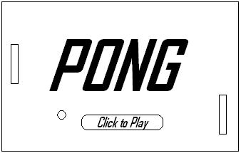
Intro:

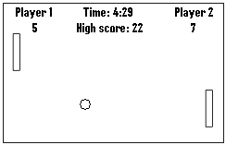
Game:

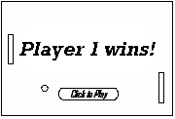
Game Over:

Java Example:
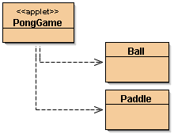
Class hierarchy chart:

Class Ball:
- properties:
  - int x, y = ball position
  - int speed = ball speed
  - int angle = ball direction
- methods:
  - void move() move the ball in its current direction
  - void reset(int xx) reset ball’s x position to xx
speed and angle to original values
  - void draw(Graphics g) draw the ball on graphics context ‘g’
- Constructor
  - Ball(int x, int y, int speed, int angle)
Class Paddle:
- properties:
  - int x, y = paddle position
- methods:
  - void move(int dy) add dy to the paddle’s y position;
  - void draw(Graphics g) draw the paddle on graphics context ‘g’
  - Boolean hitTest(Ball b) return true if the paddle is hitting ball ‘b’
Class PongGame:
- Properties:
  - Time startTime time that the game started
  - int score1, score2 player 1 and 2 scores
  - int highscore highest score so far
  - Ball ball the ball
  - Paddle paddle1, paddle2 the 2 players’ paddles
- methods:
  - public void keyPressed( KeyEvent e ) check for keys and
call paddle.move()
  - public void run() initialize variables
while timer < 5 mins
update ball positions
check for points scored
check for collisions & bounce
  - public void paint() draw ball, paddles, timer and scores
Flash Example:
The game will have one scene, with the following frames:
Frame 1: Introduction and rules
Frame 2: The actual game
Frame 3: Game Over frame
Movie Clip hierarchy:
- Root
  - Paddle 1
      - onClipEvent(enterFrame)
- check if key pressed, move
- check if off screen, if so set at edge
    - HitArea
  - Paddle 2
      - Same as per paddle 1
    - HitArea
  - Ball
      - onClipEvent(load) – sets initial values for the game
      - onClipEvent(enterFrame)
- move
- check if it is off the left or right of the screen & give score
- check if it hits the hit area of the paddles & bounce
- check if it is off the top or bottom of the screen & bounce
  - Score1
      - onClipEvent(enterFrame)
- shows the current score for player 1
  - Score2
      - Same as Score 1
  - Time
      - onClipEvent(load)
- remember the start time
      - onClipEvent(enterFrame)
- display the time
- when it reaches 5 min, go to the Game Over frame

